IDEATION PHASE
Brainstorm & Idea Prioritization Template
Field | Details
Date | 29 September 2026
Team ID | 6ab1d50c92b876d9664094bc
Project Name | Auto Ticket Classification Using Flow Designer
Maximum Marks | 4 Marks

Brainstorm & Idea Prioritization Template:
This brainstorming document identifies a ServiceNow-based solution for automatically classifying incoming tickets. The team considered practical ideas, grouped related features, and prioritized an implementable approach using Flow Designer.

Step-1: Team Gathering, Collaboration and Select the Problem Statement
Problem statement
Manually classifying incoming incident tickets takes time and can lead to inconsistent categories, priorities, and assignment groups. The proposed project uses ServiceNow Flow Designer to classify new tickets based on their short description, description, and other available fields, then route them to the appropriate support group.
Team collaboration
Team members discuss common ticket types, collect sample incident descriptions, identify classification keywords, and agree on routing rules. The team reviews exceptional cases and defines how a support agent can correct an incorrect classification.
Project objective
Reduce repetitive manual classification, improve consistency, and route common incidents more quickly while keeping unclear tickets available for human review.

Step-2: Brainstorm, Idea Listing and Grouping
Idea group | Brainstormed ideas
Ticket identification | Trigger a flow when an incident is created; read short description and description; identify common terms such as password, email, network, and laptop.
Automatic classification | Use Flow Designer conditions to set Category and Subcategory according to matching keywords or field values.
Priority and routing | Use impact and urgency to determine priority through the instance priority matrix; assign the ticket to the relevant support group.
Exception handling | Send unmatched or ambiguous tickets to a service desk queue for manual review; avoid overwriting agent corrections.
Notification and tracking | Notify the assigned group when needed; record classification outcomes and monitor incorrect or unmatched tickets.
Future enhancement | Consider advanced text classification or AI-based suggestions after the initial rule-based flow is tested.

Step-3: Idea Prioritization
Prioritization criteria: implementation feasibility, impact on ticket handling, and suitability for a Flow Designer prototype.
Priority | Selected idea | Reason
High | Incident-created trigger with rule-based keyword classification | Core feature; straightforward to prototype and demonstrate in Flow Designer.
High | Automatic category, subcategory, and assignment-group updates | Directly addresses inconsistent manual ticket classification and routing.
High | Fallback to manual review | Prevents uncertain tickets from being routed based on an unsupported guess.
Medium | Notifications and basic reporting | Useful for operational visibility after the core classification works.
Future | AI-based text classification | Requires additional capabilities, training data, and validation beyond the initial prototype.
Final prioritized solution
Build a rule-based ServiceNow Flow Designer flow that starts when a new incident is created. Evaluate the ticket text using ordered conditions, update the matching classification fields and assignment group, and route unmatched incidents to the service desk for review. Test the flow with representative sample tickets before deployment.
Illustrative classification rules
Example ticket text | Suggested category / routing
“Unable to reset password” | Access / Service Desk
“Outlook email not working” | Email / Messaging Support
“Office Wi-Fi disconnected” | Network / Network Support
“Laptop will not start” | Hardware / Desktop Support
No matching keyword | Unclassified / Service Desk review
Note: Categories and group names are illustrative; use the actual choices and assignment groups configured in the ServiceNow instance.

Project Workflow Diagram
Auto Ticket Classification Using Flow Designer — proposed rule-based workflow
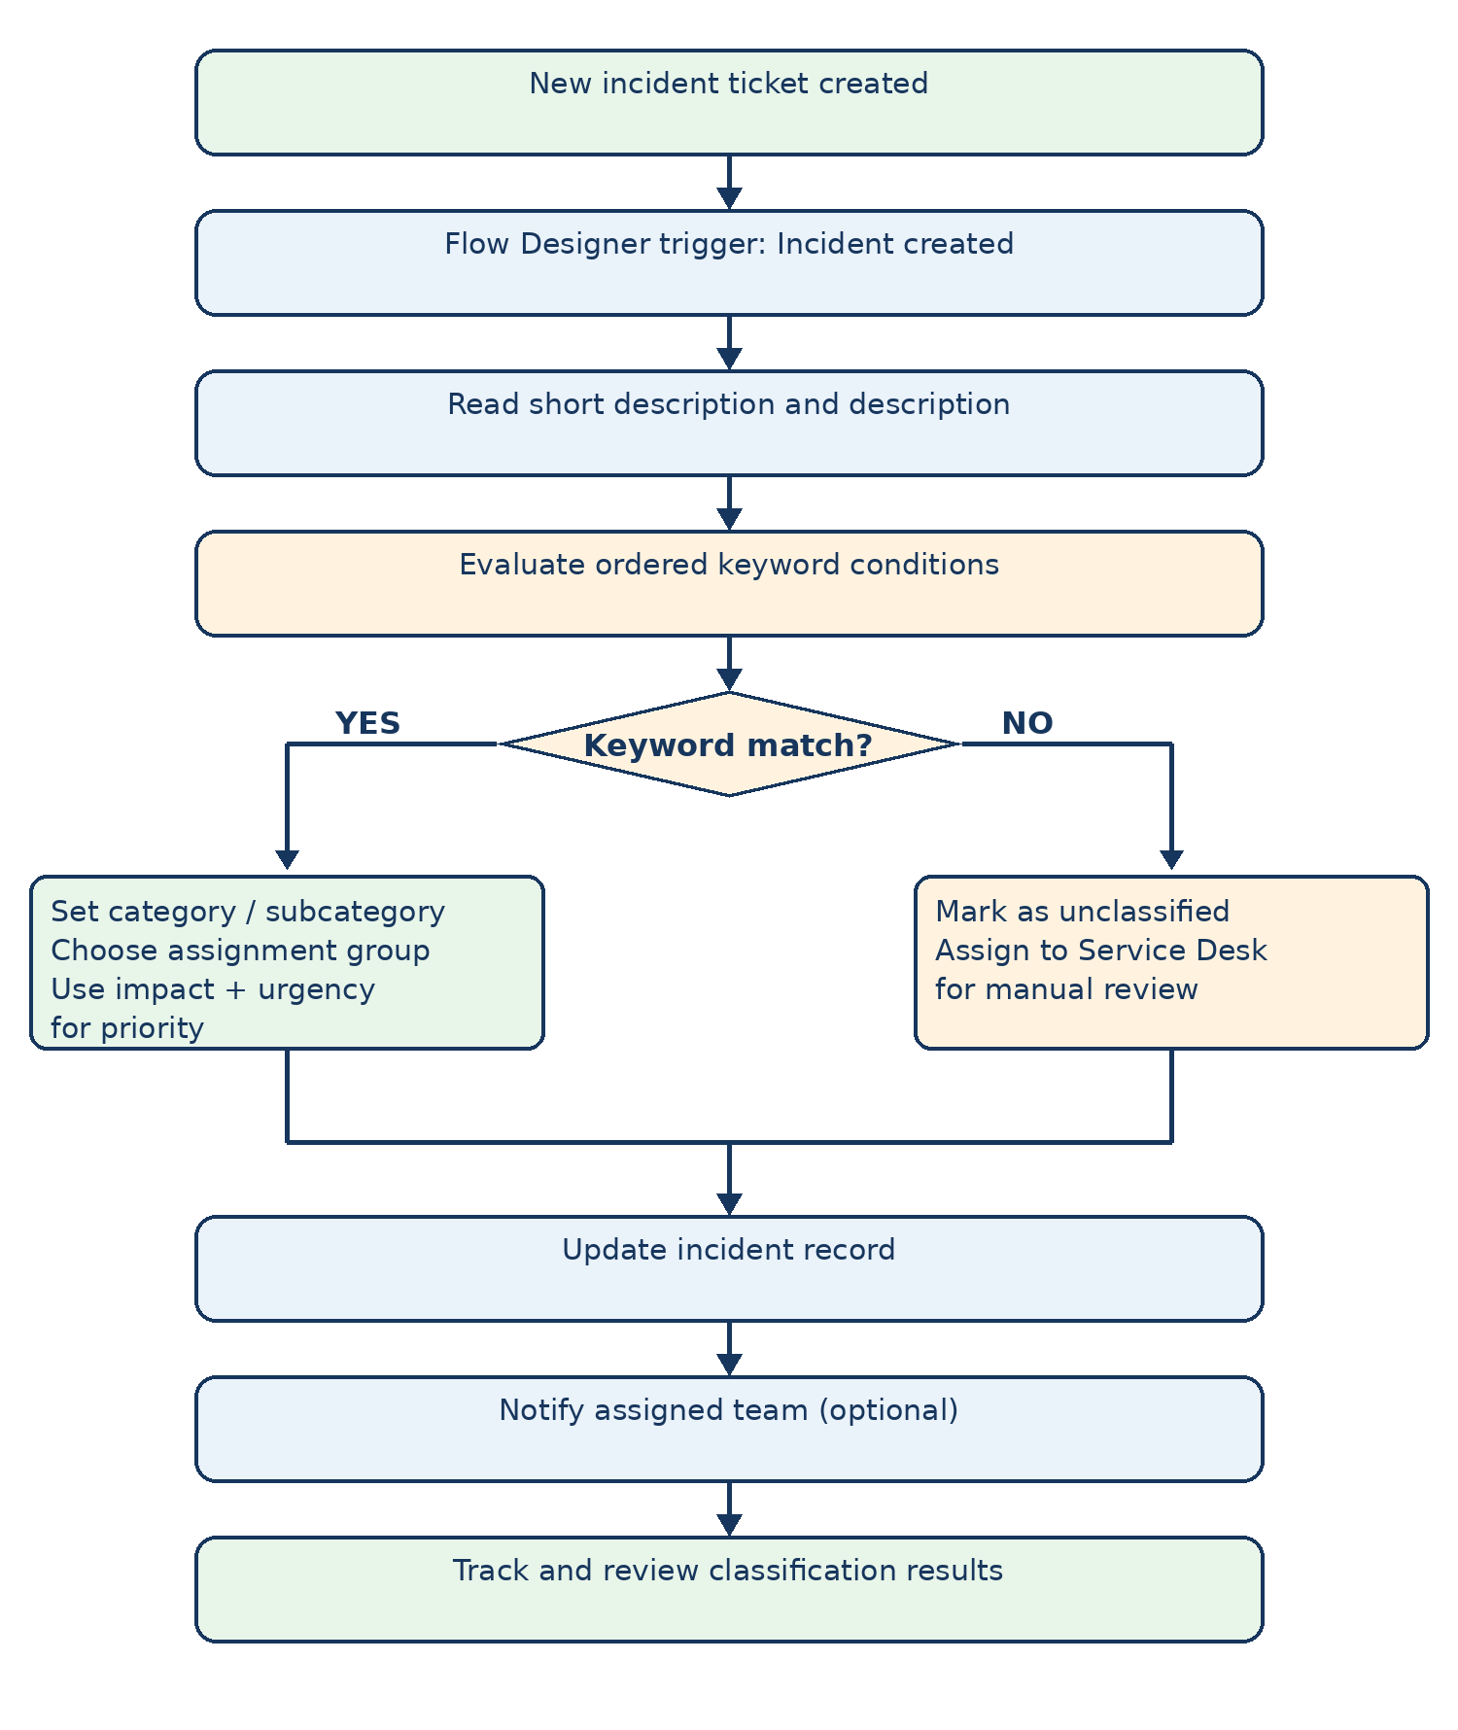
Figure: New incident tickets are checked against ordered keyword rules. Matching tickets receive classification and routing updates; unmatched tickets go to the Service Desk for manual review.

